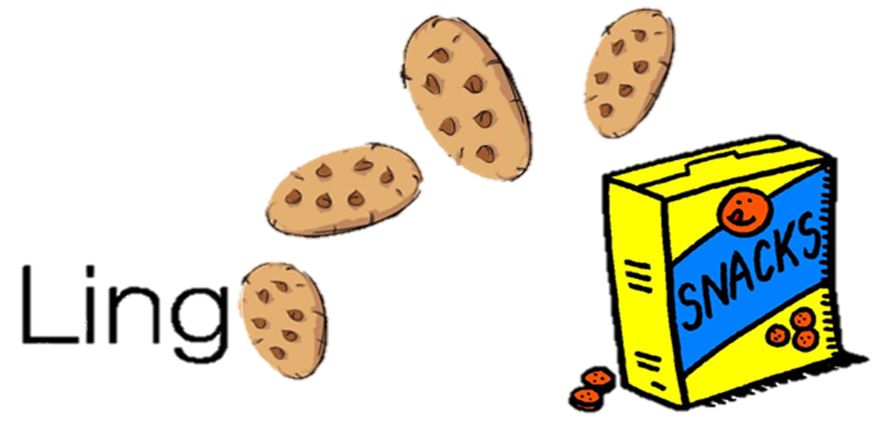 **CMPS 312 Project Phase 1**



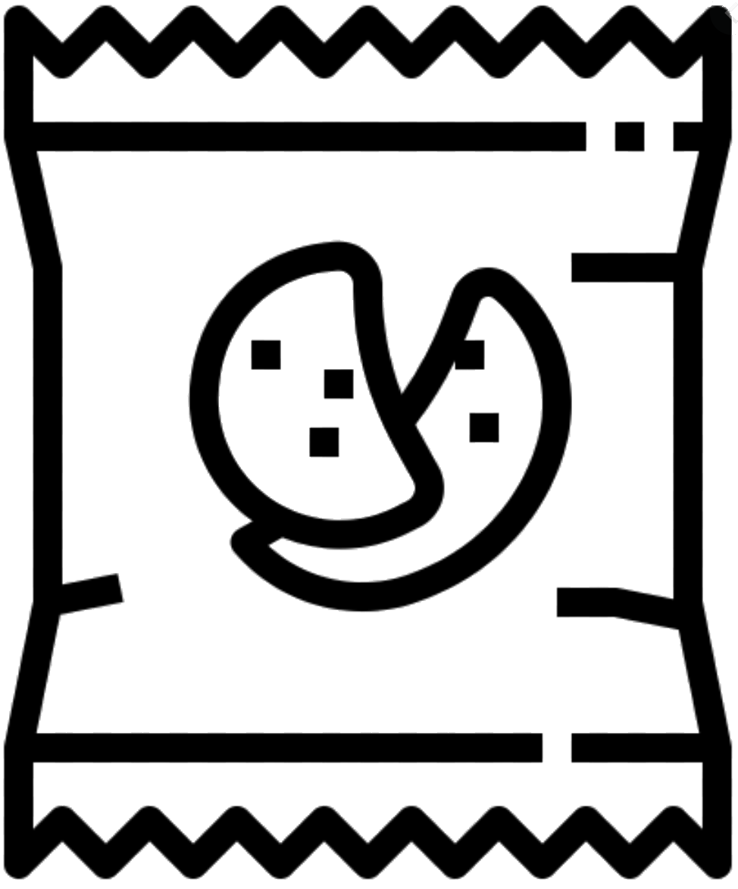

|  |  |
| --- | --- |
| **Group Id:** | G4 |
| **Group Members:** | Mohammed Abushahla 201706282  Abdulla Khedr 201702167  **Hasan Alsamra 201707182**  **Emails:**  [ma1706282@student.qu.edu.qa](mailto:ma1706282@student.qu.edu.qa);  [ak1702167@student.qu.edu.qa](mailto:ak1702167@student.qu.edu.qa);  [ha1707182@student.qu.edu.qa](mailto:ha1707182@student.qu.edu.qa); |

**Grading Rubric - In the Functionality column please specify either: *Working (completed x%)*, *Not Working (completed x%)* or *Not done*.**

|  |  |  |  |  |  |
| --- | --- | --- | --- | --- | --- |
| Criteria | | % | Functionality* | Quality of the implementation | Score |
| 1. Repositories Class Diagram. | | 5 | Working 100% | Good | 5 |
| 2) Design and implement the **UI** | | **68** |  |  |  |
|  | T1 - Login | 4 | Working 100% | No need for start screen… (less clicks the better) …  Has remember me, welcomed addition but stick the requirements to save time.  Firebase phase 2. | 4 |
| T2 - Sign Up | 4 | Working 100% | Good | 4 |
| T3 - List and search packages | 8 | Working 100% | Only allow delete for owned package. | 7.5 |
| T4 - Delete Learning Package | 4 | Working 100% | Good | 4 |
| T5 - Add/Update Learning Package, including: | 6 | Working 100% | Good | 6 |
|  | T5.1 – Add/Update/Delete Words | 10 | Working 90% | Good | 9 |
|  | T5.2 - Add/Update/Delete Definitions | 10 | Working 100% | Good… definition (need the source) | 9.5 |
|  | T5.3 - Add/Update/Delete Sentences | 10 | Working 100% | Good | 10 |
|  | T5.4 - Attach Multimedia | 10 | Working 80% | Only Icon for package done.  Multimedia for Word and Sentence not done. | 5 |
|  | T5.5 – Save the Learning Package | 2 | Working 100% | Ok | 2 |
| 3) Design and implement the **UI Navigation** | | 7 | Working 100% | Good | 7 |
| 4) Implement the entities and repositories using Kotlin | | 15 | Working 100% | Good but  - Word poorly done: Defs and sentences most likely not available when a Word is created. Hence, better not to have it in the constructor.  - DataRepository better to split it into 2 LP and Account to keep [high cohesion](https://en.wikipedia.org/wiki/Cohesion_(computer_science)) (this is an important design principle) | 14 |
| **5) Testing documentation** using screen shots illustrating the testing of UI and Repositories. | | 5 |  | Excellent | 5 |
| **Total** | |  |  | Excellent work.  LearningPackagesViewModel could be simpler. See model solution. | 92 |

**\* Possible grading for functionality** - ***Working*** (get 70% of the assigned grade), ***Not*** ***working*** (lose 40% of assigned grade and ***Not done*** (get 0). The remaining grade is assigned to the quality of the implementation.

In case your implementation is not working then 40% of the grade will be lost and the remaining 60% will be determined based on of the code quality and how close your solution to the working implementation.

Solution quality also includes meaningful naming of identifiers (according to Android naming conventions), no redundant code, simple and efficient design, clean implementation without unnecessary files/code, use of comments where necessary, proper code formatting and indentation.

**Marks will be reduced** forcode duplication, poor/inefficient coding practices, poor naming of identifiers, unclean/untidy submission, and unnecessary complex/poor user interface design.

# Repositories Class Diagram

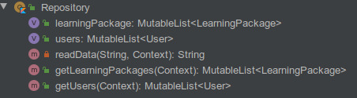

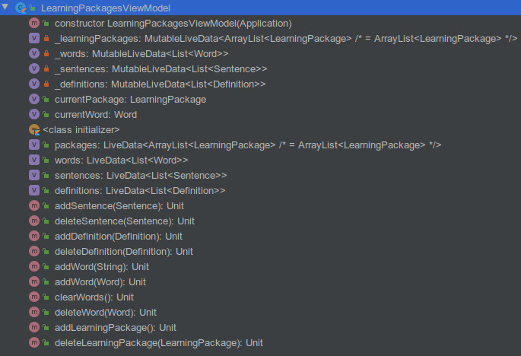

# App Navigation Diagram

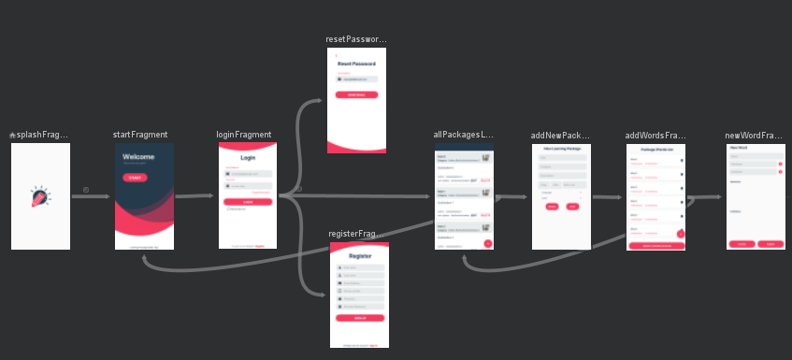s

# User Interface Testing

# T1 - Login

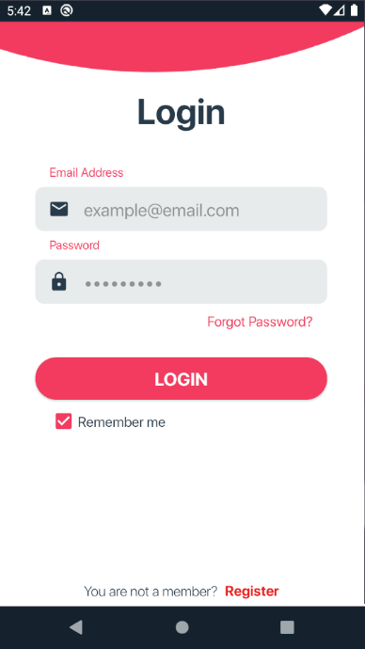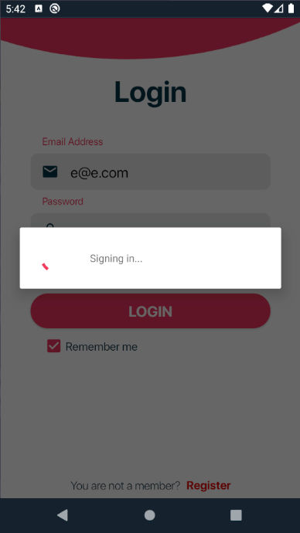

# T2 - Sign Up

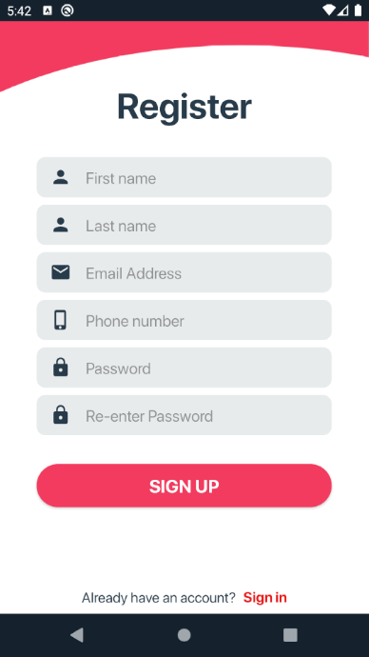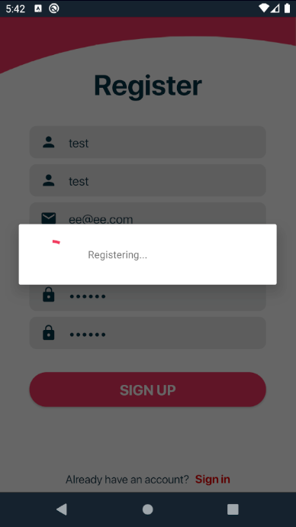

# T3 - List and search packages

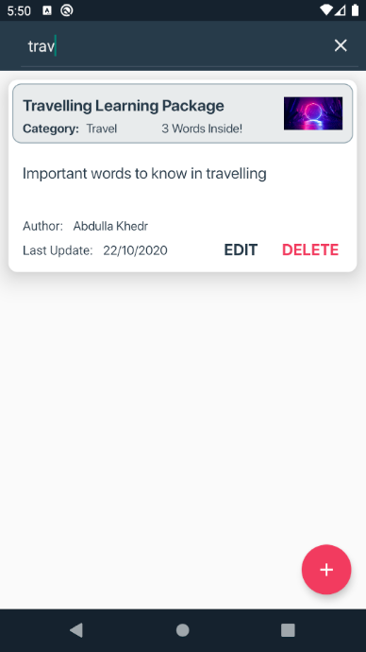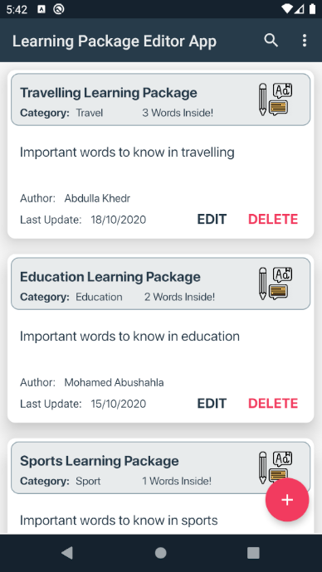

# T4 - Delete Learning Package

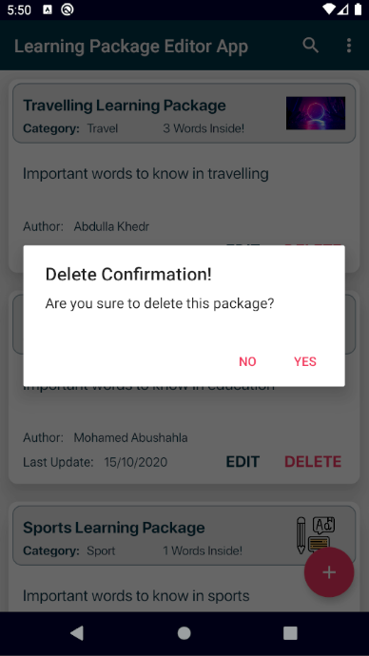

# T5 - Add/Update Learning Package

# T5.1 – Add/Update/Delete Words

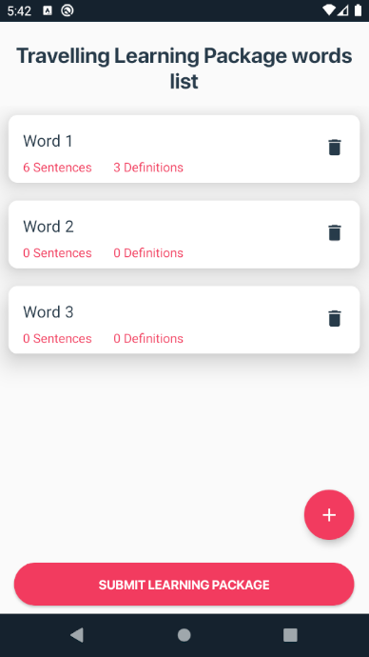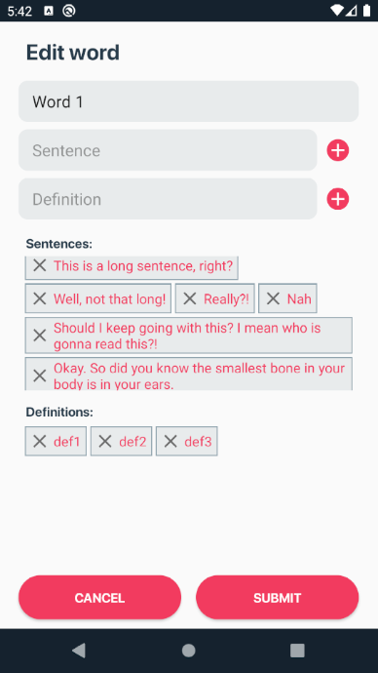

# T5.2 - Add/Update/Delete Definitions



# T5.3 - Add/Update/Delete Sentences



# T5.4 - Attach Multimedia

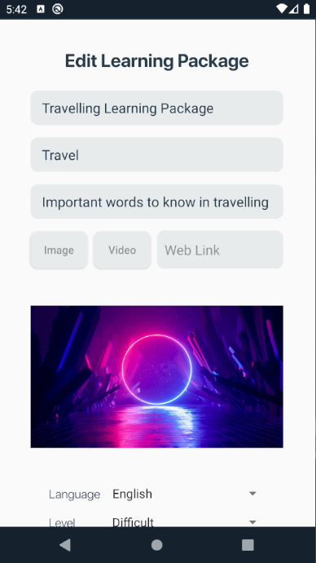

# T5.5 – Save the Learning Package

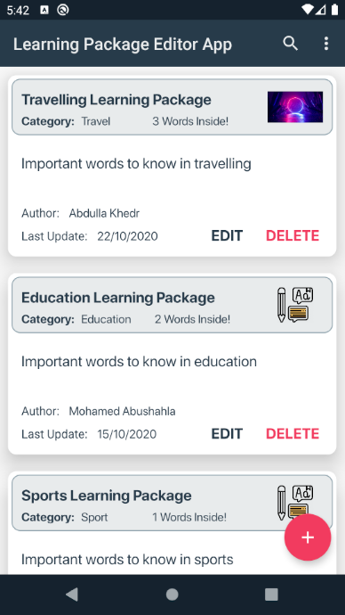

# Summary of team member contributions

Our team worked together using online meeting platforms most of the time, therefore we, together, have contributed almost equally to the project and managed to keep in touch with each other in order to make sure that we finalize the project and obtain the best possible results. While it is true some of us worked, at some point, independently of each other and had to implement some minor parts of the project individually, due to some conflicts in our schedules, we made sure to keep up with each other's work, so we can have a complete understanding of all parts of the project.